UML Diagram

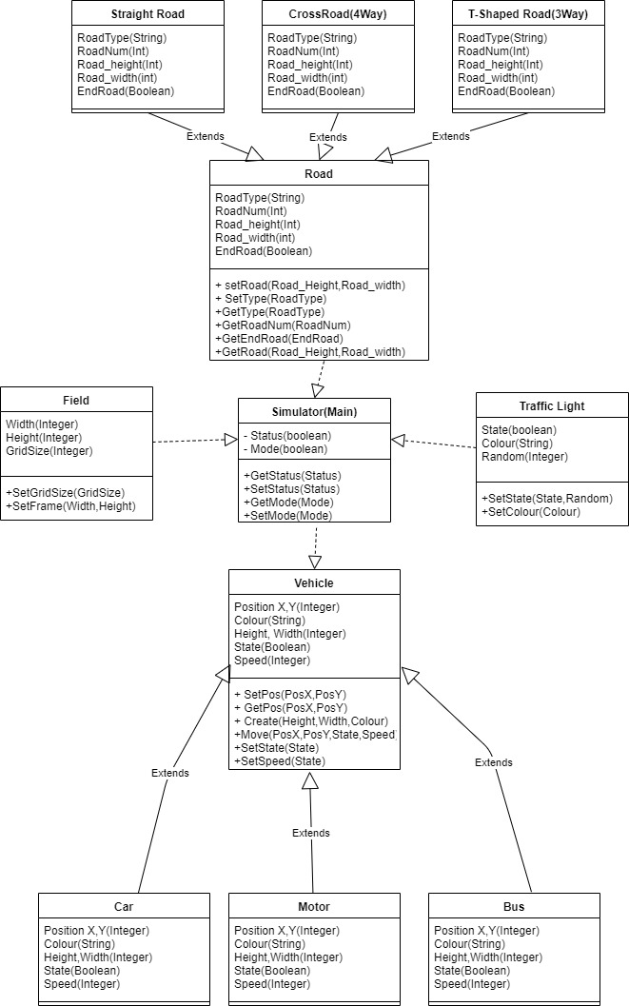

User Story 1:

As a user, I want to differentiate Vehicles

Priority: Low

Estimate: 30 Minutes

Test: Try to add Car, Bus, Motorcycle.

User Story 2:

As a user, I want to edit the city roads and able to save and works when I load my old city planning.

Priority: High

Estimate: 5 Hours

Test: Try Save, Load Features in City Editing Modes and Try to choose the road type.

User Story 3:

As a user, I want to see Any Vehicles to run in the road with working Traffic Lights.

Priority: High

Estimate: 5 Hours

Test: in Road that already planned see different types of Vehicles and Stop when the traffic light is red and vice-versa.

User Story 4:

As a user, I want to How many Vehicles in the city.

Priority: Medium

Estimate: 2 Hours

Test: See City Status on Top menu of How many vehicles in the city.

User Story 5:

As a user, I want to see if the Vehicles randomly move and disappears when it reaches the end of the city road.

Priority: Medium

Estimate: 2 Hours

Test: See Each Vehicles and see if its move randomly and gone as it reach the end of the city road.

User Story 6:

As a user, I want the road to have two lanes.

Priority: Medium

Estimate: 3 Hours

Test: See Vehicles that moved at the same road with different directions

**User:**

* Users set their own City Name in Editing Mode.
* Users can choose Road Type and where to put it in Editing Mode.
* Users can See How many Vehicles in their city.
* Users can Choose between simulation and City Editing Mode.
* Users can create new City, Edit, Open, Save city.
* Users can set Update Rate, Run and Stop Simulator.

**System:**

* Applications will have size based on user’s screen size.
* Applications have 2 main features: City Editing and Simulation Modes.’
* In Simulation Modes provided setting for update rate of vehicles, Stop and Run Simulator.
* In Editing Modes provided setting for set road, traffic on selected placed on the city.
* 2D top-down view of the grid with road, traffic, Vehicles.
* Randomly Spawn Vehicle with the rate set by users.
* Grid for simulation or editing mode will have size 10x10.
* Vehicles Types: Car, Motor, Bus.
* Show Statistics on City how many Vehicles, Traffic Light and Overall Avg Speed and Current City name.
* Road will have two lanes.
* The Size of the Vehicles are already set.
* Road Shapes in this simulator is Straight, 4-way, T junction or 3 way.
* Traffic Lights is Red, Green, Yellow.